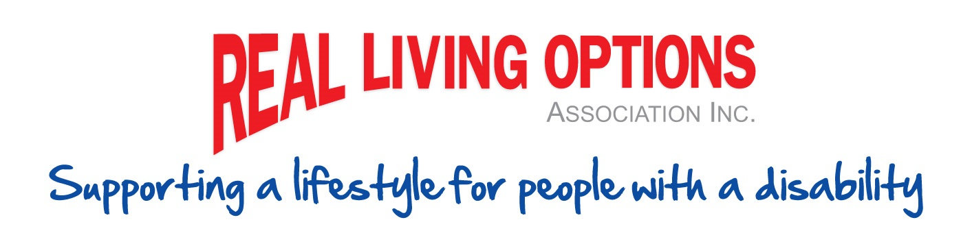

Get-together
followed by the
2025 Annual General Meeting Social

When: Monday 3rd November 2025
Time: From 5pm (AGM starts at 6:00pm)
Where: Spinal Life Healthy Living Centre Conference Room. 2-4 Smith Street, Cairns North

Please RSVP by Monday 27th October 2025
Phone 4035 5886 or email admin@reallivingoptions.com.au

